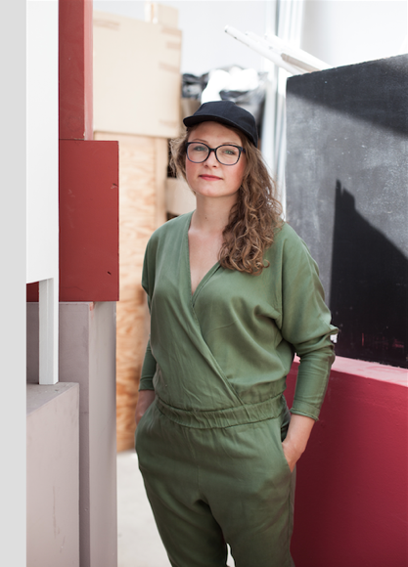

Born and raised in a small village Kolonia Koplany( near Białystok), Poland, Iza Tarasewicz’s works serve as temporary conduits for a meeting of substances, energies, locations, temporalities, intonations, and concepts, which the artist identifies as only events in a continuous series of material and symbolic interactions. In her work, basic and humble ingredients undergo complex transformations, often through processes borrowed from routines found in the daily bustle of village life. Her sculptural installations take the form of modular, flexible, mobile, and reconfigurable display systems that combine a raw and modest functionalism with formal logics found in the natural world, scientific experimentation, and graphs and diagrams—figures of thought and charts of relation that systematize knowledge and data and abstractly describe the interaction of phenomena.

Her installation The Means, the Milieu (2014) was originally exhibited in the basement of Objectif Exhibitions, an old cheese factory turned non-profit gallery, in Antwerp. In it, thousands of metal rods filled the space, hanging from the ceiling in a suspended modular lattice intercut by clusters of overlapping, almost cellular, hexagonal forms. The piece turned out to be a subterranean mycobiota: a number of growing eukaryotic fungal organisms were inserted into the geometric structure which were in turn encircled by base materials and stalactite receptacles, a half-kilometre of caoutchouc (natural rubber) and ochre-covered hemp rope, and fibre plates of ash-infused caoutchouc. Within the installation, the artist propagated Reishi mushrooms—some of the oldest cultivated fungus used for medicine—which served as both

The elements of the work have since taken on different scales and have occupied various settings, including suspended throughout a hidden stairway in the Zachęta National Gallery in Warsaw, and as self-supported individual units in various exhibitions (Palazzo Santa Margherita, Modena, Italy; Preset Future, Artissima, Turin, Italy; Kunsthalle Bratislava, Slovakia)

Tarasewicz’s objects often function as tools: contingent, temporary, and variable engines of information that chart lines of flight between scales, dimensions, and events, displaying the consequences of entering objects into a system. Tarasewicz’s TURBA, TURBO (2015) was a development of the artist’s recent preoccupations with chaos theory, information and matter compression, and the visual effects of those processes. The starting point was a modernist circular flower stand that Tarasewicz associated with the Large Hadron Collider at CERN near Geneva – a machine that accelerates elementary particles to near the speed of light and collides them with each other. 25 massive metal hoops are connected by a system of small metal frames, on which the artist arranges various raw experiments with iron-oxide pigments and other materials. Connecting the infinitely large to the infinitesimally small by using prosaic proportions, Tarasewicz’s work is an abstract equivalent of a collision of particles that produces chaos.

Arena (2014-2015) is a 50-meter-long circle of hemp fibres and caotchuouc, a thick rope forming a loop. The black circle is hung from the ceiling and can be rearranged to conform to any space or circumstance. Its title refers to ancient enclosures where events would take place: the amphitheater, the stadium, and the marketplace, the first stages of politics, performance, debate, and public communication. The line marks a perimeter, a boundary line, but also demarcates a site for presentation, a closed circuit for activity. It operates as a variable frame, a temporary tool that inaugurates a system, a relation. It is a form of soft and fluctuating architecture, breaking up space through a transparent and simple contour. Correlating the delineation of space with the primary act of drawing, it is an instrument for mark-making, for both bringing entities together and dividing. Crisscrossing through space, the composition constantly changes with the viewer’s position, flattening from some points of view and extending outwards from others, blurring the line between two-dimensionality and three-dimensionality. Producing almost-calligraphic paths, the work traces a route of loops and twists, generating an abstract choreography for the eye and the body.

Iza Tarasewicz lives between Kolonia Koplany(near Białystok, Poland), Munich, and various other territories. She is the winner of the “Views 2015-Deutsche Bank Award”, regarded as Poland’s most important art prize, which was presented at Zachęta National Gallery in Warsaw. Recent solo exhibitions include ULTRA HIGH TURBA TURBO III(background noise), Kostka Gallery, Prague, Czech Republic; Turbulence Soon Appears, Trapez Gallery, Budapest, Hungary; Loop de Loop, Bikini, Lyon, France; Sorry for All The Ups and Downs, Syntax Project, Lisbon, Portugal; Reverse Logistics, BWA Warszawa, Warsaw, Poland (all 2015); By the apparent impossibility of arranging signs, Arsenal Gallery, Białystok, Poland; The Means, the Milieu, Objectif Exhibitions, Antwerp, Belgium; Collaborating Objects Radiating Environments, Kunstlerhaus Bethanien, Berlin, Germany; Strange Attractors, Polnisches Institut Berlin, Germany (all 2014) and Clinamen, Krolikarnia X. Dunikowski Museum of Sculpture, National Museum, Warsaw, Poland (2013). Recent Group exhibitions include the 32nd Bienal de Sao Paulo 2016; the 11th Gwangju Biennale, Korea; HYPERCONNECTED, Moscow Biennial of Young Art, Moscow, Russia; A Thousand Horsepower, Can Trinxet Factory, L’Hospitalet, Barcelona, Spain; Contemporary Art from Poland, European Central Bank, Frankfurt, Germany; La Memoria Finalmente, Arte in Polonia 1989-2015, Palazzo Santa Margherita, Modena, Italy; Unfolding Constellations, CCA Toruń, Poland (all 2016); Dust, CCA Zamek Ujazdowkski, Warsaw, Poland; Gardens, Zacheta National Museum, Warsaw, Poland; Procedures for the Head. Polish Art Today, Kunsthalle Bratislava, Slovakia (all 2015); As You Can See: Polish Art Today, Modern Art in Warsaw, Poland (2014).

